



Contact:

**Angelo Virgilio**

[Angelo.virgilio@ecin.ca](mailto:Angelo.virgilio@ecin.ca)

Mobile: 416.605.1296

IXChariot – INSTALLATION GUIDE

Bell Canada; ATL Lab

|  |
| --- |
| **Revisions** |

| Version | Primary Author(s) | Description of Version | Date Completed |
| --- | --- | --- | --- |
| 0.1 | Arijit Saha | First Draft version |  |

|  |
| --- |
| **Review & Approval** |

Requirements Document Approval History

| Approving Party | Version Approved | Signature | Date |
| --- | --- | --- | --- |
|  |  |  |  |
|  |  |  |  |

Requirements Document Review History

| Reviewer | Version Reviewed | Signature | Date |
| --- | --- | --- | --- |
|  |  |  |  |
|  |  |  |  |
|  |  |  |  |

Contents

1. Installing WinRAR 3

2. Installing Python 6

2.1 Setting up Environmental Variables and Path 9

2.2 Updation of PIP and Setup Tools 12

3. Install wxPython 2.8.12.1 13

4. WebAPI 16

5. Starting the Project 19

6. Installing the Requirements 22

7. Open RIDE GUI 24

8. Load Project in RIDE 25

## Installing WinRAR

* + - * 1. Click on the link below to download:

<https://www.win-rar.com/start.html?&L=0>

* + - * 1. Run the installer.
        2. Accept the license agreement by clicking on the Install button.

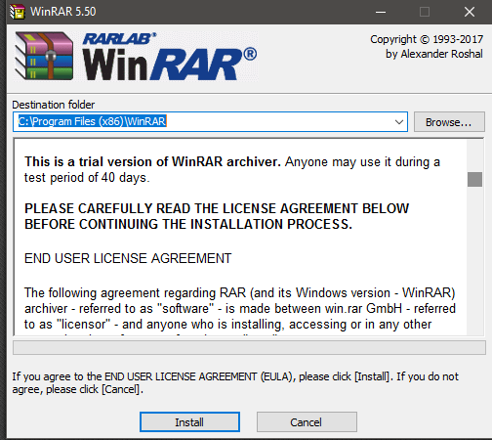

* + - * 1. It will start to install.

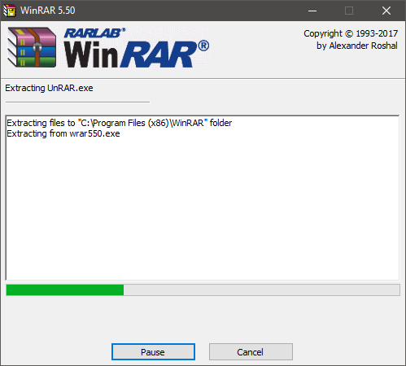

* + - * 1. Select the types of zipping extensions and click Ok.

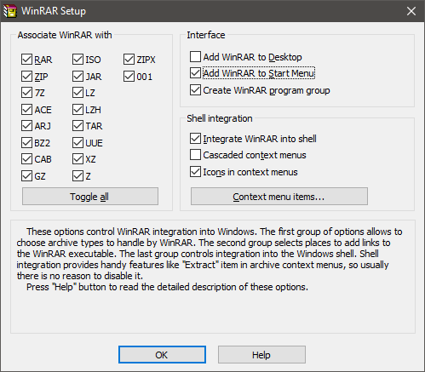

* + - * 1. Once the installation is successfully completed, click on the Done button.

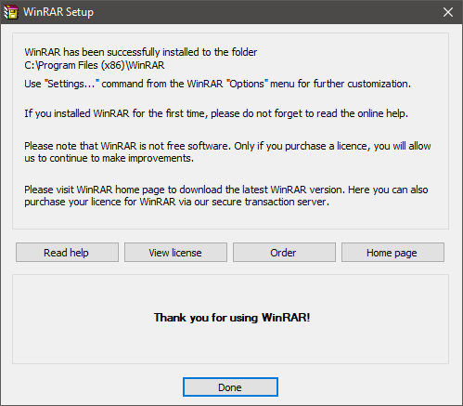

## Installing Python

1. The user has to download Python 2.7.9 and above.
2. To download Python, click on the link below:

<https://www.python.org/downloads/release/python-279/>

1. The user has to download the installer file based on the requirement of OS.

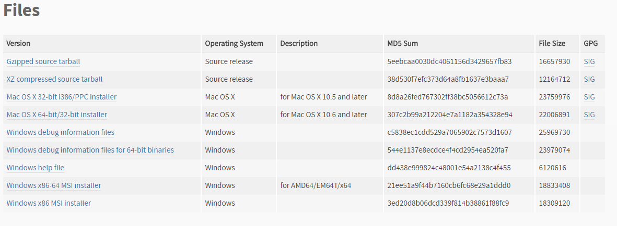

1. Run the installer.
2. Select “Install for all users” and click on the Next button to continue.

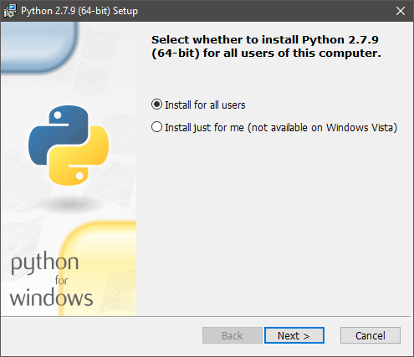

1. On the directory selection screen, keep the installation directory as “**C:\Python27\**” and click “**Next**.”.

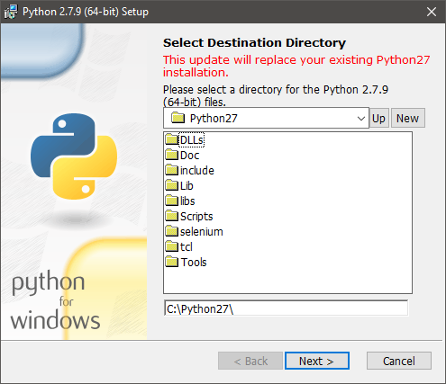

1. On the customization screen, scroll down, to check the options for installing and then click “**Next**”.

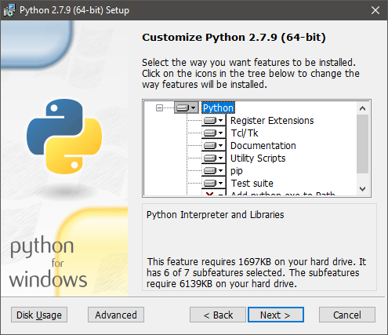

1. It will start to install. Wait till it is installed.

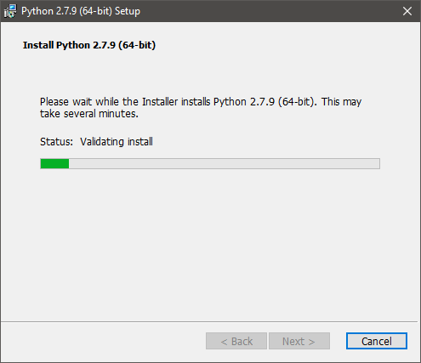

1. Click on the Close button after the it is installed successfully.

### Setting up Environmental Variables and Path

1. Now the user has to set the path in the environmental variables of the system.
2. In order to set, Hit Start, type “advanced system settings,” and then select the “View advanced system settings” option. In the “System Properties” window that opens, on the “Advanced” tab, click the “Environment Variables” button.
3. Open Start > Settings > Control Panel > System > Advanced > Environment Variables. There are User variables and System variables and the difference between them is that User variables affect only the current users, whereas System variables affect all users.

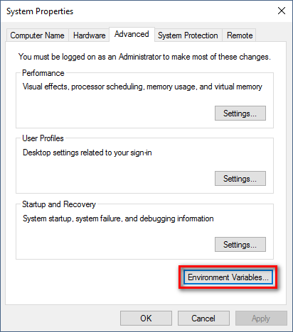

1. Find the “**Path**” variable under “**System Variables**” and select it.
2. After selection, click “**Edit**”. A window will open for where the path variables will be listed. Adding new path variable and editing existing variables can be done.

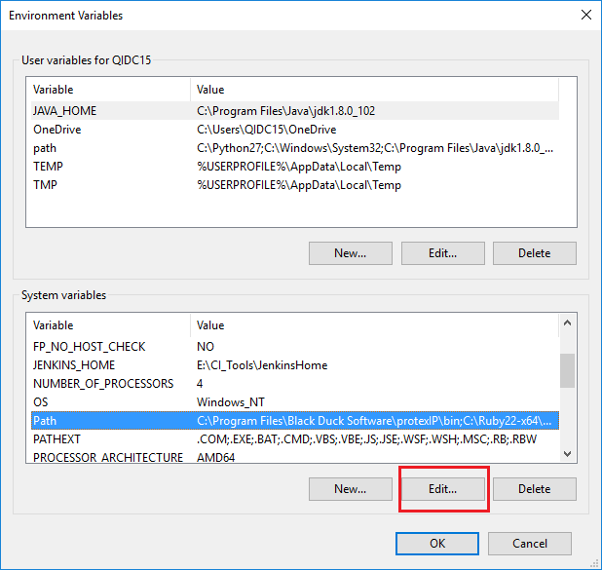

1. Click “**New**” button and enter data in the format

Enter “**C:\Python27**”.

Again click “**New**” and enter “**C:\Python27\Scripts**”.

Click “**Ok**”.

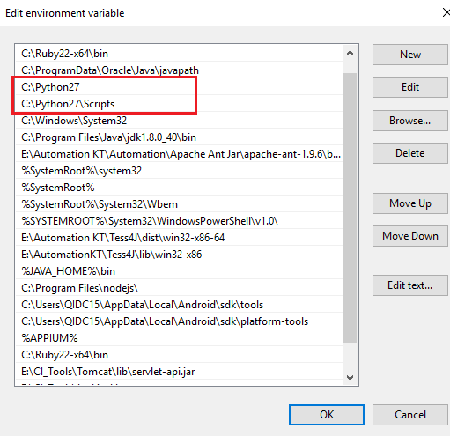

1. From command prompt, type “python –V” to make sure that Python has been installed properly.

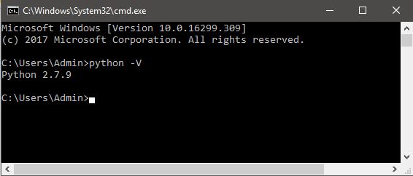

### Updation of PIP and Setup Tools

1. To update the PIP and setup tools, open a command prompt.
2. Now enter the command as “python -m pip install --upgrade pip” and press Enter.

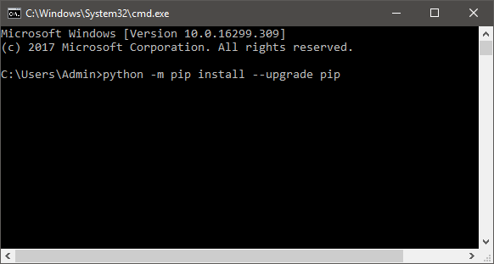

1. After updating of Pip, in the same command prompt enter the command “python install --upgrade setuptools” and press Enter.

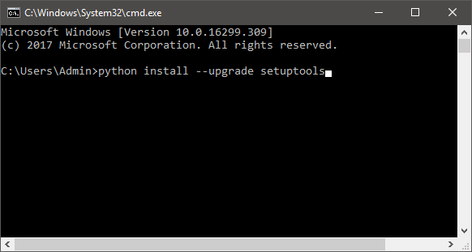

## Install wxPython 2.8.12.1

wxPython is a **GUI toolkit** for the [Python](http://www.python.org/) programming language. It allows Python programmers to create programs with a robust, highly functional graphical user interface, simply and easily. It is implemented as a Python extension module (native code) that wraps the popular [wxWidgets](http://wxwidgets.org/) cross platform GUI library. Following section describes the process to install the wxPython and the specific version supported.

1. Download the wxPython installer from <https://sourceforge.net/projects/wxpython/files/wxPython/2.8.12.1/>
2. Open the link and click on “**wxPython2.8-win64-unicode-2.8.12.1-py27.exe**”

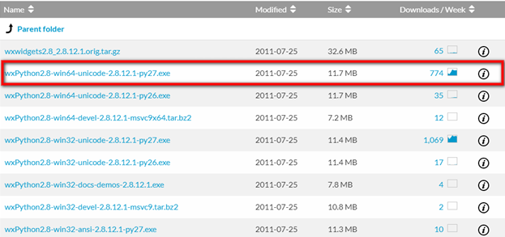

1. Run the installer and click “**Next**” to continue the setup.

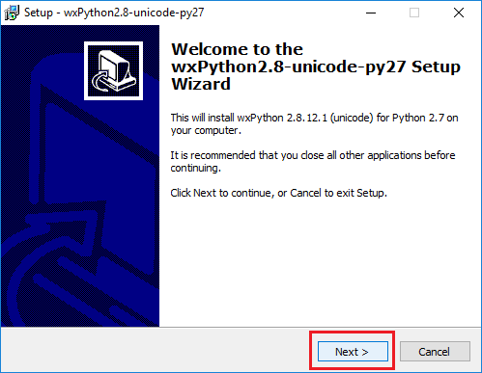

1. In the window, click on radio button to accept the terms of agreement.

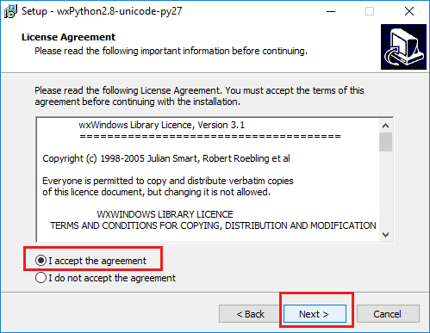

1. Click “**Next**” after keeping the default directory “**C:\Python27\Lib\siti-packages**” chosen for the installation for this program.

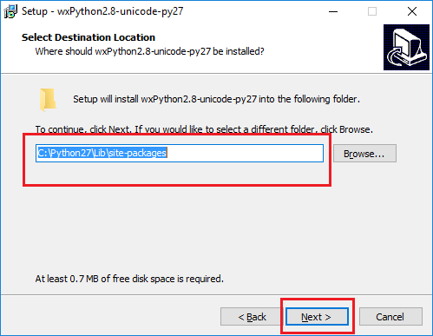

1. Click on “Next” after selecting “**Full Installation**” from the drop down and selecting the checkbox for “**Make this install be the default wxPython**”.

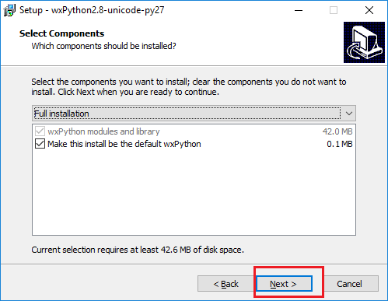

1. The installation process will follow and complete after this.

A command line interface will open and the installation will continue.

If the “**ReadMe.txt**” file is open, then close it.

## WebAPI

1. The user has to login into the IxChariot website using their credentials.
2. Then on the top right-hand side, click on the settings icon.

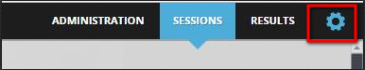

1. Under the settings, click on the Help button.

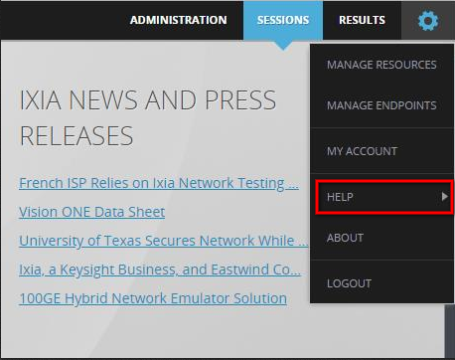

1. From the dropdown, click on the Python API Libraries.

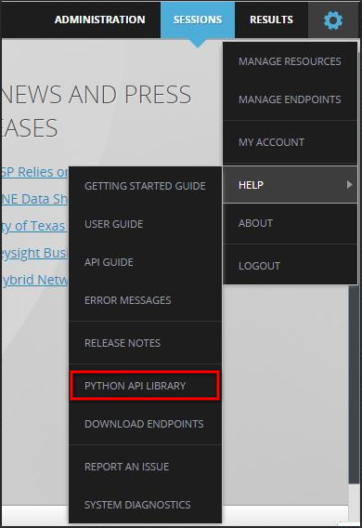

1. The file will get downloaded in the defaults download folder in the form of zip file.
2. Unzip the file and store the folder under the C: drive with the folder name as **WebAPI**.

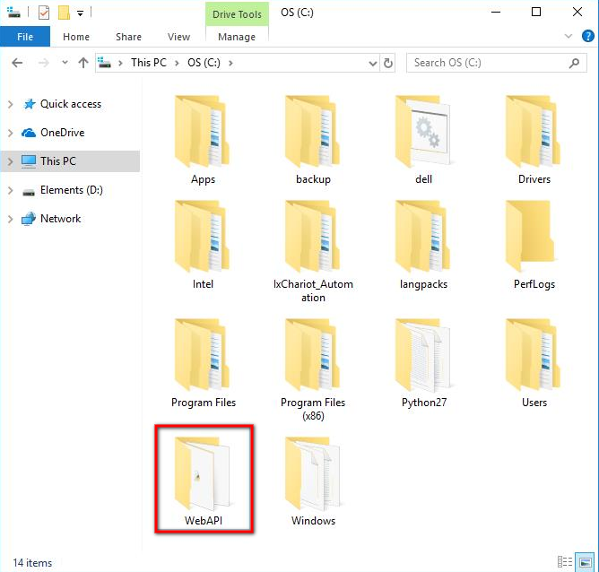

1. Now set the path in the environmental variables of the system settings.

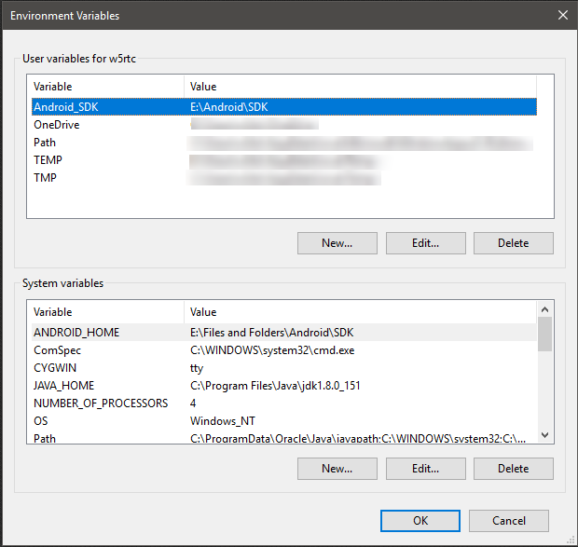

1. Click on the new button under the **System Variables** and enter the variable name as **PYTHONPATH** and variable value as “**C:/WebAPI**”.

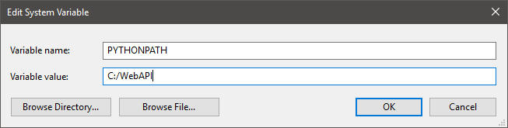

1. After setting the path for **PYTHONPATH**, click on the Ok button.

## **Starting the Project**

The user has to unzip the downloaded file and save the folder in the **C: drive**.

Note: The installation process of WinRAR which is used to unzip is mentioned in the Installation Manual.

1. The user can find the zip file in the defaults **Downloads** folder.

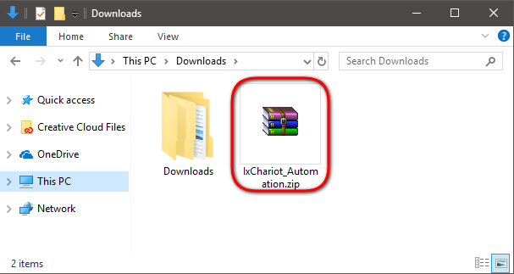

1. To unzip the file, right click on the file.
2. From the dropdown, select **Extract files**.

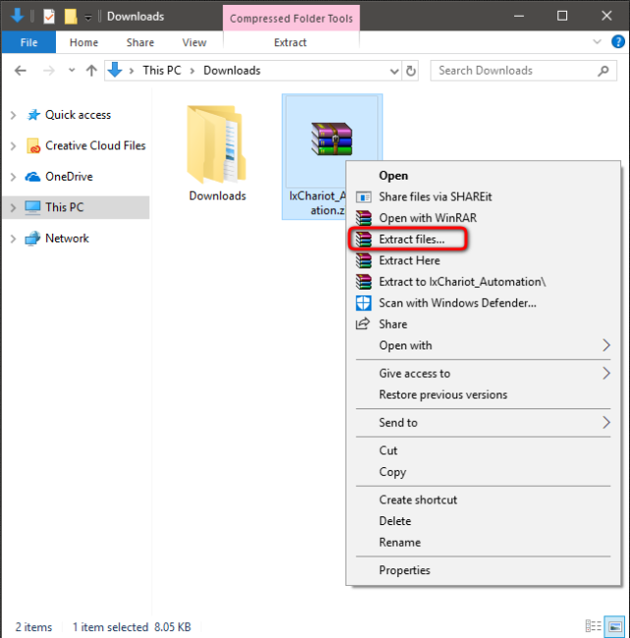

1. A pop up window will come up.

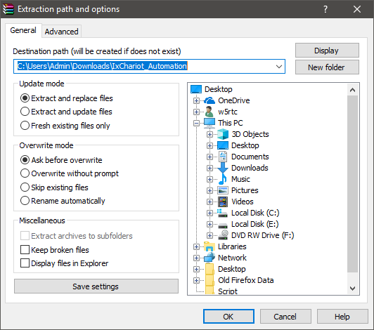

1. Choose the **C: drive** and click on the Ok button.

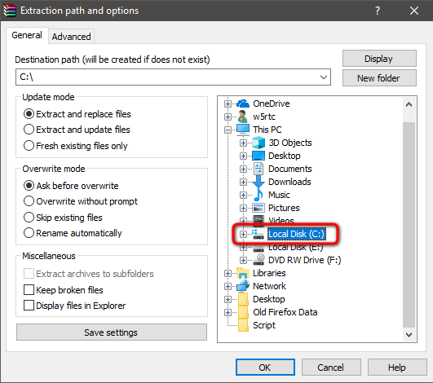

1. Then it will start the unzipping process.
2. After the completion, the user will find a folder with the name **IxChariot_Automation** in the **C: drive**.

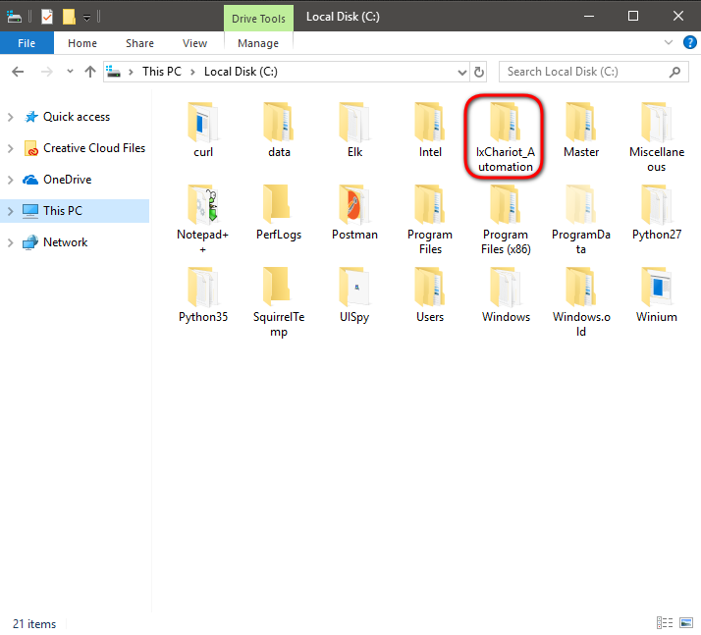

## **Installing the Requirements**

1. Go to the folder of **IxChariot_Automation** under **C:** drive.



1. Under the IxChariot_Automation folder, the user will find tools folder, click and open.

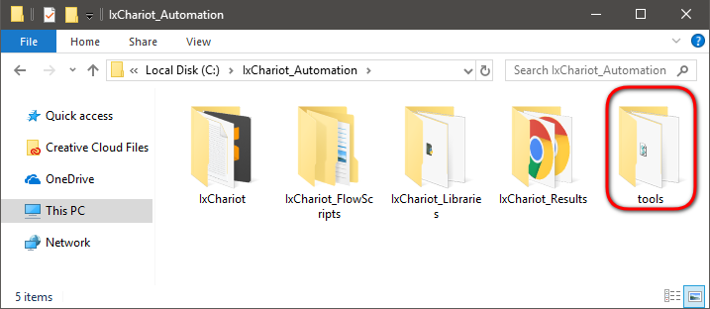

1. In the URL bar, type the command as “cmd” and press Enter.

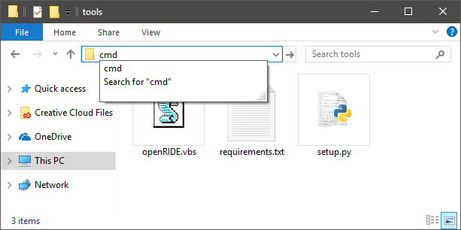

1. Giving the command, it will open the command prompt.

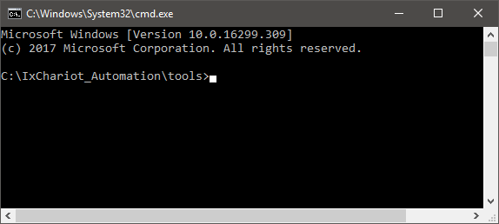

1. Then enter the command as “pip install -r requirements.txt” and press Enter.

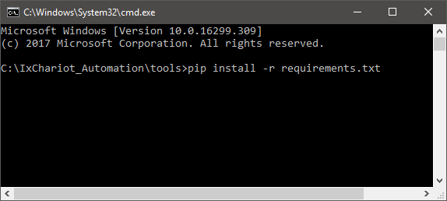

1. Wait till the installation process is complete.

## **Open RIDE GUI**

In order to view and execute the test cases, the user needs to open the RIDE GUI from the shortcut named “ROBOT Automation RIDE” which is present on the Desktop.

1. Double click on the shortcut icon to open the RIDE GUI.

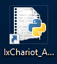

1. RIDE GUI should open.

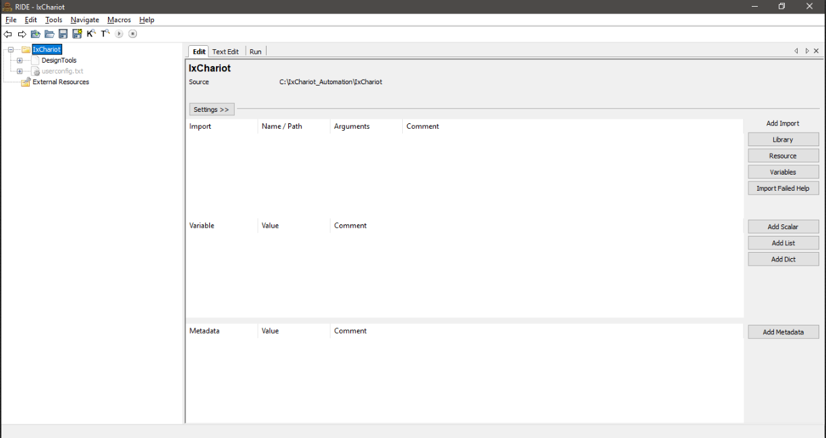

## **Load Project in RIDE**

After the RIDE GUI opens, the user needs to load the project folder so that they get the view of the test case structure and the different test cases that are present for execution.

* 1. Now on the RIDE GUI, click on “File” and click on “Open Directory” to open the file system and choose the project to be loaded from local folder.

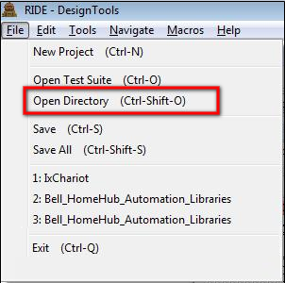

* 1. From the window that opens, click to expand the contents of drive “C:\”.

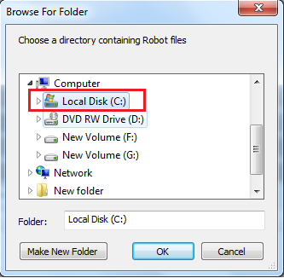

* 1. After the contents of the driver expand, click on “**IxChariot_Automation**” folder again to expand and show the contents.

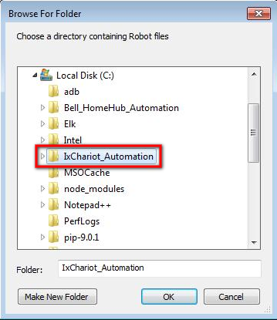

* 1. As the folder contents expand, click on “IxChariot” folder to select.

Click “Ok” button.

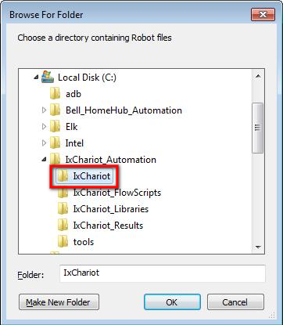

* 1. The RIDE GUI will have the contents loaded as shown.

